Operational Requirements

for

FogWire

Oct 28, 2009

To be developed by

The 5d’s

Ricardo Viera, Dmitri Sharlot, Joe Everett

Program Managers

Anthony Sinatra

Project Manager

1. General Description of Operational Capability
   1. Mission Area Description

FogWire is a security software used to hide messages from unintended recipients. The software is intended for single users accessing files and or documents on their computer consoles.

* 1. Mission Need

Messages that are intercepted by third party users may have valuable information not intended for the third party to read. This need for secrecy is the purpose of FogWire, which is to mask important messages from prying eyes and make them unreadable.

* 1. Description of the Proposed Product or System

FogWire will open a message from file or allow a text message to be created within its software interface. With the opened or created message, FogWire will encrypt the message or Decrypt the message depending on whether the user is receiving a message or sending it. The masking of the message addresses the problem of outside parties reading unsecure important data and performs the task of keeping a users message secret.

* 1. Mission the Proposed System will Accomplish

FogWire will allow a user to mask their message by form of encryption and make it unreadable. The message will then be allowed to be open only by the intended recipient.

* 1. Operational and Support Concept

The System will encrypt a message with a public recipient key. The recipient will open the message using the private inverse version of the encrypted key. The recipient and only the recipient has the private key therefore only the recipient is able to decipher the encrypted message.

Both recipient and user will work with their intended messages via FogWire software interface.

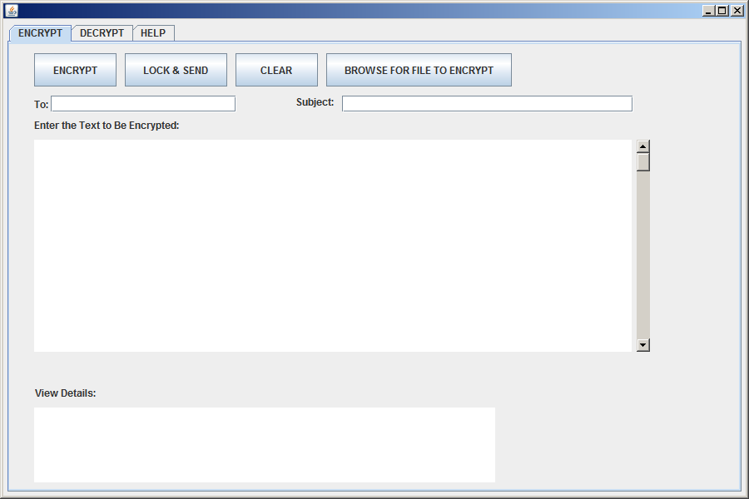

1. Threat

The intended threats are hackers, users with network listeners that may receive message from senders with the purpose of reading them. If and when the users message is compromised the message is indescribable to anyone except its intended recipient.

1. The System shortfalls

User may not be able to encrypt any file , ie .pdf, .doc. The software is intended for text up to the end of the entire software creation phase. Therefore , without more time than currently allowed the software is intended for text messages.

1. Capablilities Required
   1. Fogwire will complete its tasks by having an encrypt/decrypt function, a text area , and a send function. The encrypt function will apply the algorithm that will mask the message. The Text area will display the original message or show the new message being created. The send function is used to send the encrypted message to another user via email.
   2. Fogwire must encrypt a message and decipher this message back to its original form at the minimum the message is of extension .txt. Fogwire should allow this message to be sent to a recipient via email.
2. System Support

The software is fully functional upon receipt. It is also easy to use with instructional document attached.

* 1. Maintenance

FogWire is self maintained.

* 1. Supply

FogWire is software that may be used on a PC. The software can be ran on any pc by simply copying the initial software and installing it. Tools and or supplies are not necessary.

* 1. Support Equipment

FogWire will have an email for problems and or questions to the system for continued FogWire software improvement and development of newer versions.

1. Schedule

System will be available by the end of the Software Engineering I course at Pace University by December 23, 2009.

1. The system will be made available to Professor Marchese and current 5d partners. It will be free for them. The target price will be negotiated after the completion of the project and the course at Pace University Software Engineering I (fall 2009).

Sigantures

Program Managers

Project Managers